Table 1: Characteristics of study participants.

Variable | Samples (N=267)
Female | 242 (88)
Age, years | 49.80 (10.52)
Cholesterol, mg/dl | 371.26 (234.79)
Triglycerides, mg/dl | 124.98 (65.28)
Albumin, gm/dl | 3.52 (0.40)
Urine Copper, ug/day | 100.77 (88.27)
Alkaline Phosphatase, U/L | 1996.61 (2115.48)
Serum Bilirubin, mg/dl | 3.33 (4.60)
Platelet, ml/1000 | 261.77 (93.13)
Prothrombin time, sec | 10.74 (1.01)
SGOT, U/ml | 124.12 (56.72)
Drug Treatment | 136 (49)
Ascites presence | 19 (7)
Hepatomegaly presence | 142 (51)
Spider presence | 80 (29)
Edema presence | 42 (15)
Histologic Disease  Stage 1  Stage 2  Stage 3  Stage 4 | 12 (4)  59 (21)  111 (40)  94 (34)
Event of Death | 111 (40)
Follow up time, years | 5.42 (3.25, 7.36)
Follow up time, mean (25th, 75th) percentiles. Values reported as mean (standard deviation) or as sample size and (%).

Table 2: Cox Proportional Hazard Regression Model Results
Variable | Sample Size (Number of Events) | Coefficient | Hazard Ratio | 95% Confidence Interval (Hazard Ratio) | P-Value
Drug | 136 (57) | 0.0261 | 1.026 | (0.6916,1.5234) | 0.897
Treatment
Sex | 242 (90) | -0.1062 | 0.899 | (0.497, 1.6271) | 0.7256
Female
Age | 276 (111) | 0.0255 | 1.026 | (1.004, 1.0476) | 0.0176
Log(Bili) | 276 (111) | 0.7397 | 2.095 | (1.6374, 2.6812) | <.0001
Albumin | 276 (111) | -0.8422 | 0.431 | (0.2589, 0.7167) | 0.0012
Copper | 276 (111) | 0.0019 | 1.002 | (0.9996, 1.0042) | 0.1034
SGOT | 276 (111) | 0.0025 | 1.003 | (0.9988, 1.0063) | 0.181
Prothrombin Time | 276 (111) | 0.3122 | 1.366 | (1.1086, 1.6843) | 0.0034
Stage 2 | 59 (14) | 1.3026 | 3.679 | (0.449, 30.1457) | 0.2248
Stage 3 | 111 (41) | 1.5922 | 4.914 | (0.6417, 37.6331) | 0.1253
Stage 4 | 94 (55) | 1.8249 | 6.202 | (0.8048, 47.7957) | 0.0798
Uno's Concordance Statistic = 0.7949

Figure 1: (DFBetas) Graphical Outlier Analysis for the Cox PH Model

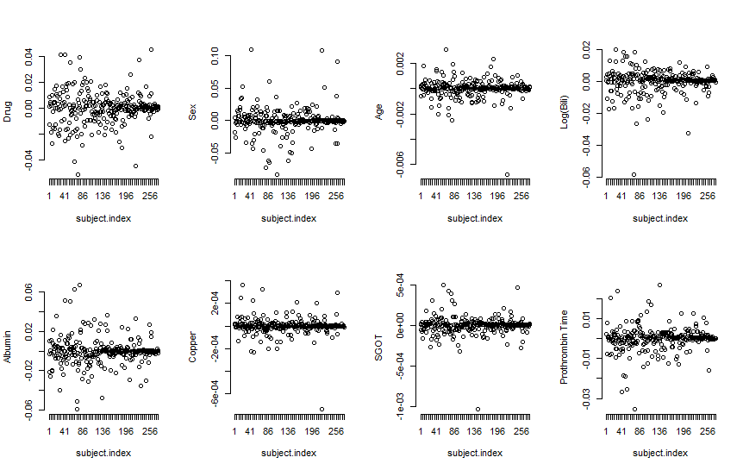

Figure 2: Graph of the Schoenfeld Residuals for Cox PH model
